Task 1:
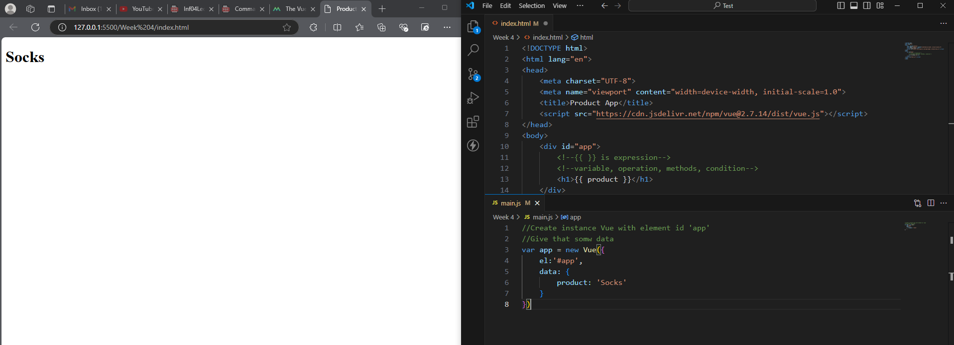
The beginning of a Vue application with a Vue instance. Calling the element with id by using el property in Vue instance. The product will show by passing reference by using {{ }} expression. The property data in Vue instance passed the product data into the product in h1 tag by the {{ }} expression.
Task 2: To dynamically change the sock image in the src attribute when the data changes, the v-bind attribute is used. The v-bind directive dynamically binds an attribute to an expression, with src being the attribute and the expression enclosed in “”.
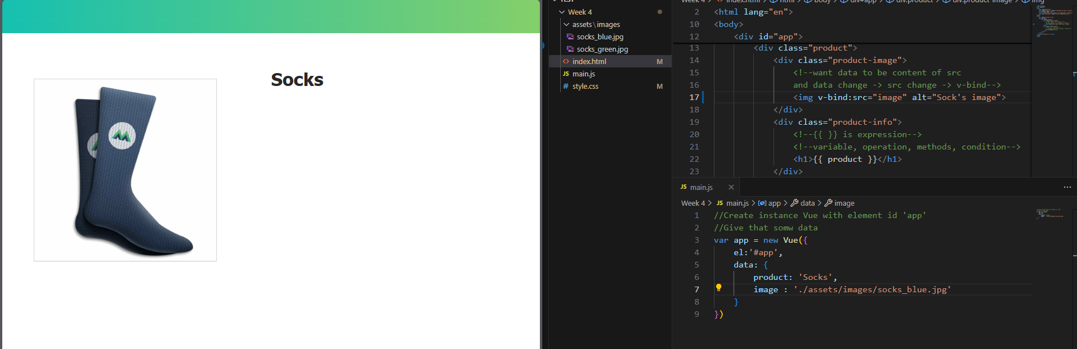
Task 3:
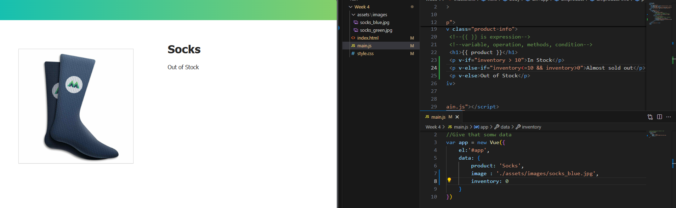
Using condition v-if, v-else-is and v-else to render elements. However, v-if add or remove the element from DOM. If the app needs an element to frequently toggle on and off the page, instead of v-if, we can use v-show which makes the visible on or off.
Task 4:
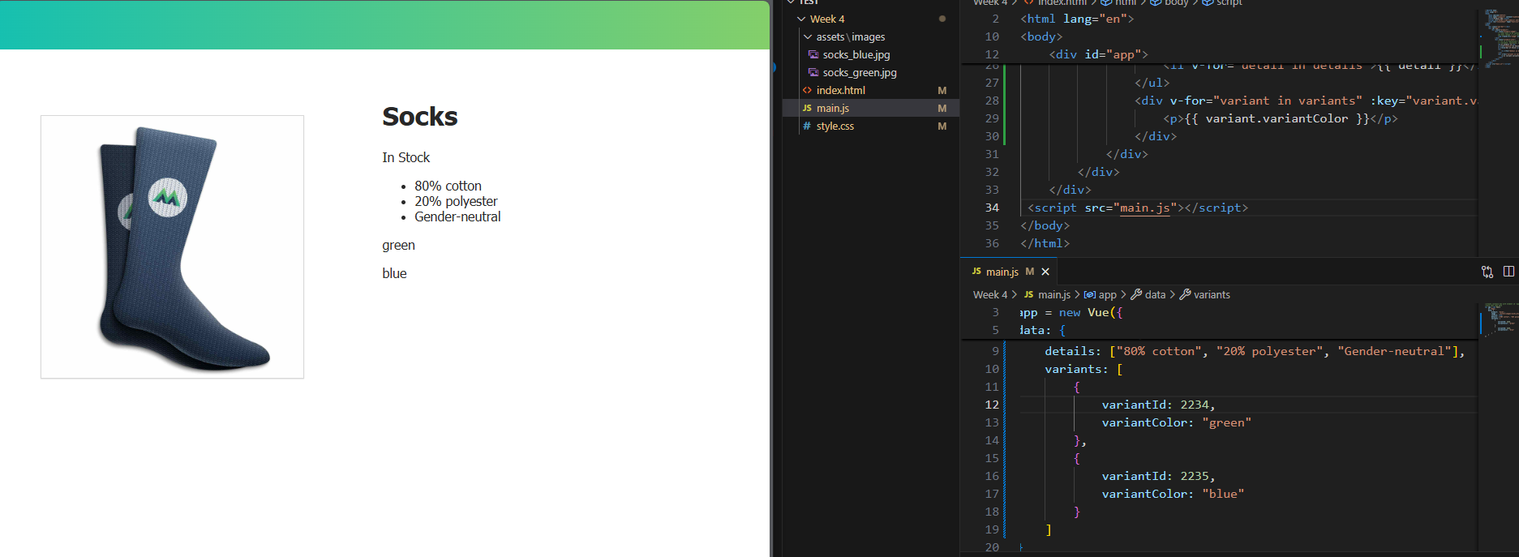
Showing the list of details by using loop v-for. Detail is iteration through each element in details. Can also use the same with an array of objects and use dot notation to display values from the objects. Binding each rendered element
Task 5:
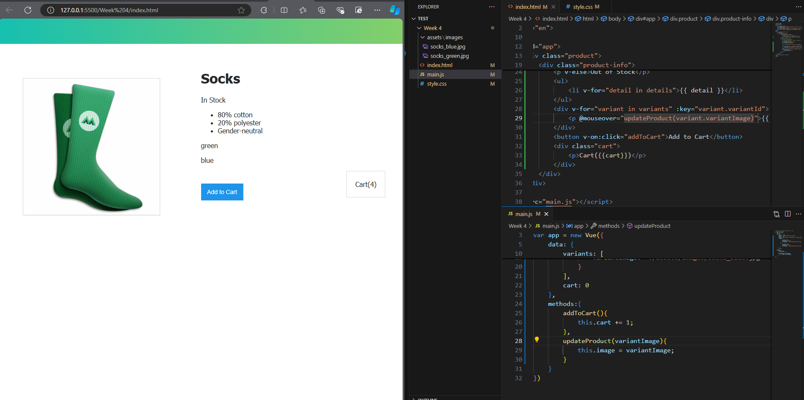
Using v-on:click to listen for a click action, and the expression will implement when that click event happens. Creating a function in methods property annd use this function. A shorthand for v-on is @. I also learned the function with passing value.
Task 6:
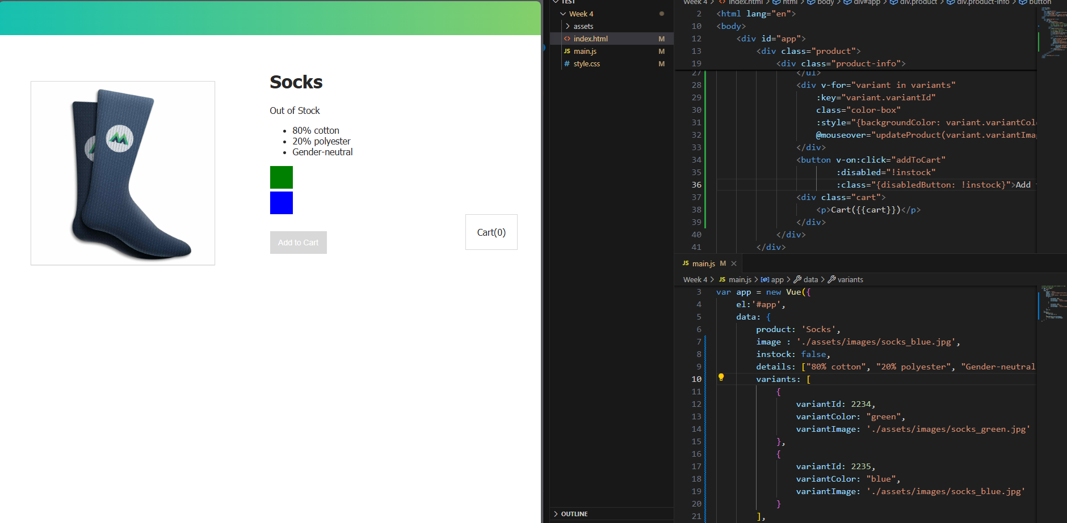
I learned that data can be bound to an element’s style attribute and class. The expressions inside class binding to evaluate whether a class should appear or not
Task 7:
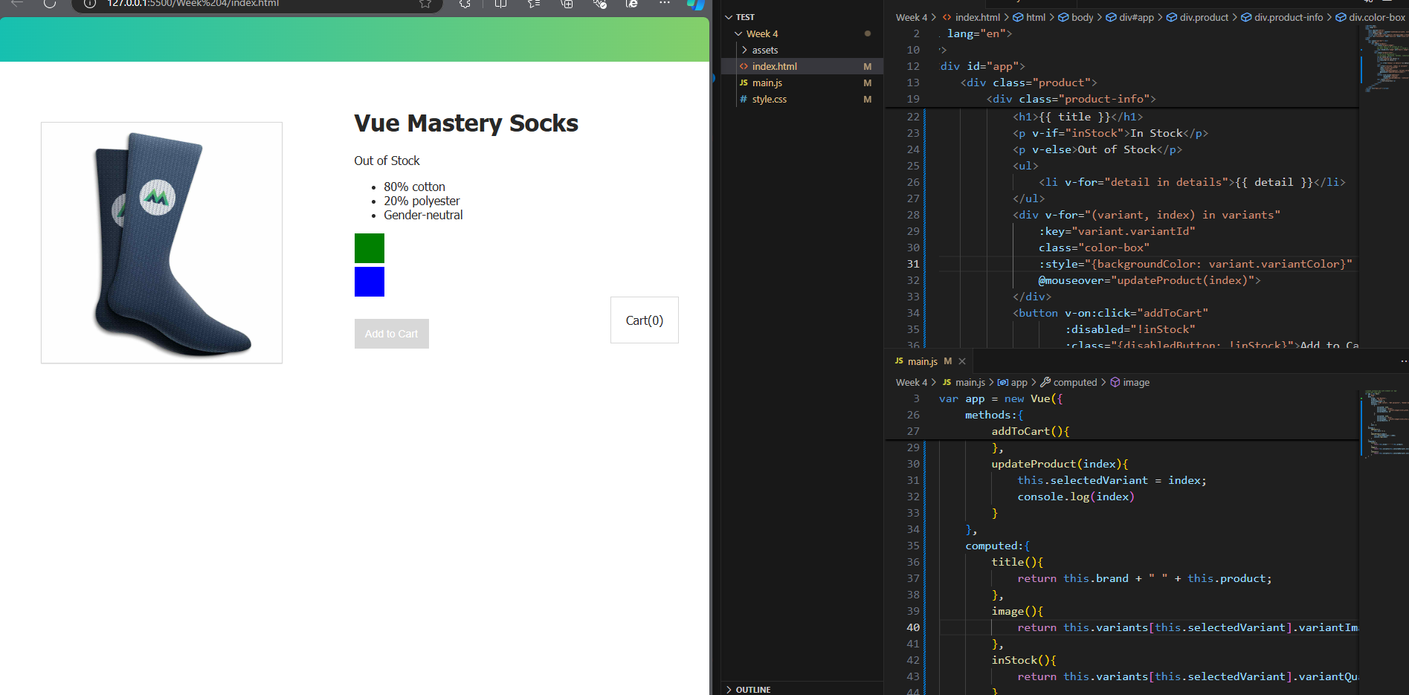
Using computed property instead of method. The computed property is cached. This is used for an expensive operation that I do not want to rerun every time I access it

